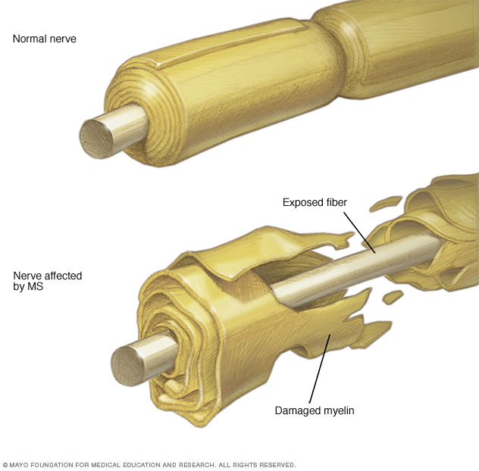

**MULTIPLE SCLEROSIS**

*Information for Patients*

**Risk Factors**

* Age – MS is most commonly diagnosed in those between the ages of 15-40.
* Sex – Women are 3 times as likely to have MS compared to men
* Latitude – People who live at higher latitudes are more likely to develop MS

**Manifestations of MS**

Since MS is characterized by damage and inflammation of the myelin sheath, symptoms can present in a multitude of ways. The most common clinical manifestations include:

* Impaired balance and reflexes, dizziness, vertigo
* Bladder dysfunction, including incontinence and nocturia
* Bowel dysfunction (constipation/diarrhea)
* Short term memory impairment
* Depression and mood lability
* Fatigue and muscle weakness
* Visual blurring, loss of vision in one eye
* Numbness and tingling
* Muscle spasticity (flexor and extensor spasms) and tremors
* Heat intolerance (Uthoff’s Phenomena)
* Sexual dysfunction

**Living with MS**

If you have MS, there are many things you can do to improve your health outcomes and allow you to live a healthy life with your disease. These include:

* *Managing stress* 🡪 promotes well-being, energy, and delays onset of relapse
* *Proper Nutrition* 🡪 helps promote energy, well being and healing
* *Skin Care* 🡪 proper skin care reduces risk of pressure ulcers, contractures, and skin breakdown
* *Prevention of Infection* 🡪 intake adequate fluids, be up to date on your vaccinations
* *Physical Therapy Exercises* 🡪 helps body maintain functionality in a safe manner

**Treatment Options & Management**

* **Pharmacological Therapy** 🡪 Drugs used for MS treatment are known as Disease Modifying Therapies. These drugs aim to reduce inflammation in the central nervous system and reduce severity and length of relapses. 11 DMTs have been approved by Health Canada for treatment for MS
* **Rehabilitation** 🡪 services such as, physiotherapy, occupational therapy and speech language pathology, can help mitigate symptoms, maintain independence, and improve quality of life.
* **Complementary & Alternative Therapy** 🡪 therapies to be used in conjunction with conventional treatment to help mitigate symptom. They include, but are not limited to yoga, mindfulness meditation, acupuncture, magnetic therapy, reflexology, massage therapy, cannabis use, and vitamin supplements etc.

**Multiple Sclerosis – What is it?**

**Multiple Sclerosis (MS)** is an autoimmune disease that affects the central nervous system (brain and spinal cord). Specifically, the body attacks the myelin sheath (protective and insulating covering around nerve cells). Myelin is important for helping conduct nerve signals within the nervous system. The immune system attacks the myelin, causing myelin damage and inflammation. Damage to myelin interrupts nerve signal conduction, distorting or completely interrupting nerve signal transmission, resulting nerve deterioration and damage. There are 3 known types of MS:

**1. Relapsing-Remitting MS** 🡪 characterized by unpredictable but clearly defined periods of varying lengths periods of symptomatic flare ups, followed by a period of recovery and remittance in symptoms.

**2. Progressive MS** 🡪 occurs in a percentage of people with relapsing-remitting MS and is characterized by a loss of the relapsing/remitting periods and a slow progression of symptom persistence and increasing disability.

**3. Progressive Relapsing MS** 🡪 characterized by steadily worsening symptoms from onset of diagnosis.

Schematic showing how the immune system damages myelin in the central nervous system